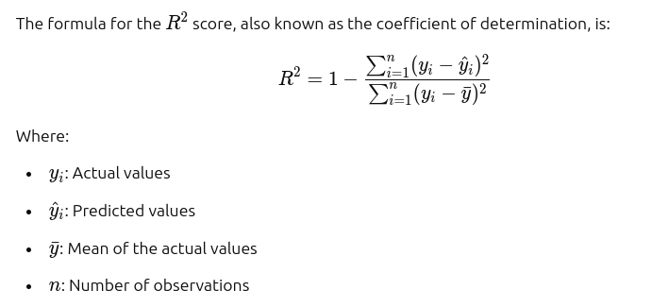
Varies from 0 to 1.

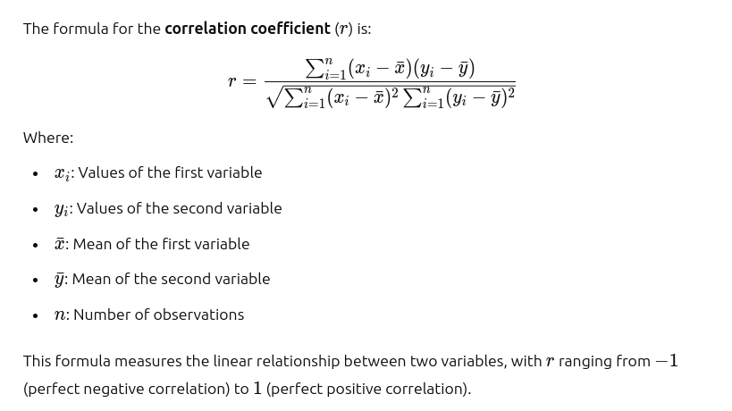
Iterrows
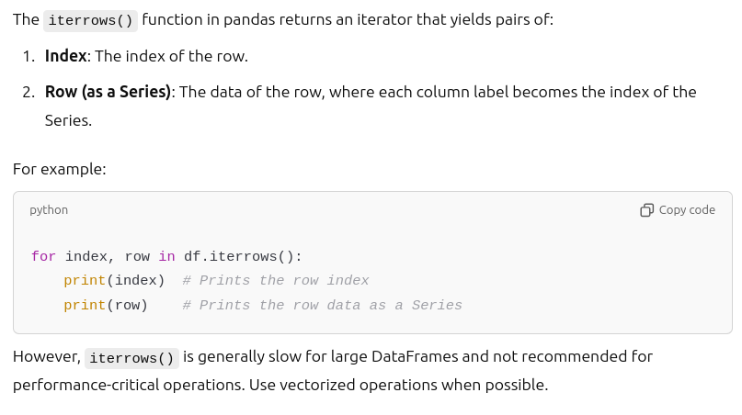
The output generated by the above is presented in terms of the dictionary, index is the row number , in dictonary, the name of teh column:data of the column, this what the returns of iterrows.

